Lab 3: Component Modelling and Architectural Pattern Selection
Problem Statement #14, Healthcare and Telemedicine: Corporate Mental Wellness and Counseling Platform
Name | Dhanush Shankar Reddy
SRN | PES1UG24AM083
Section | B

1. Component diagram
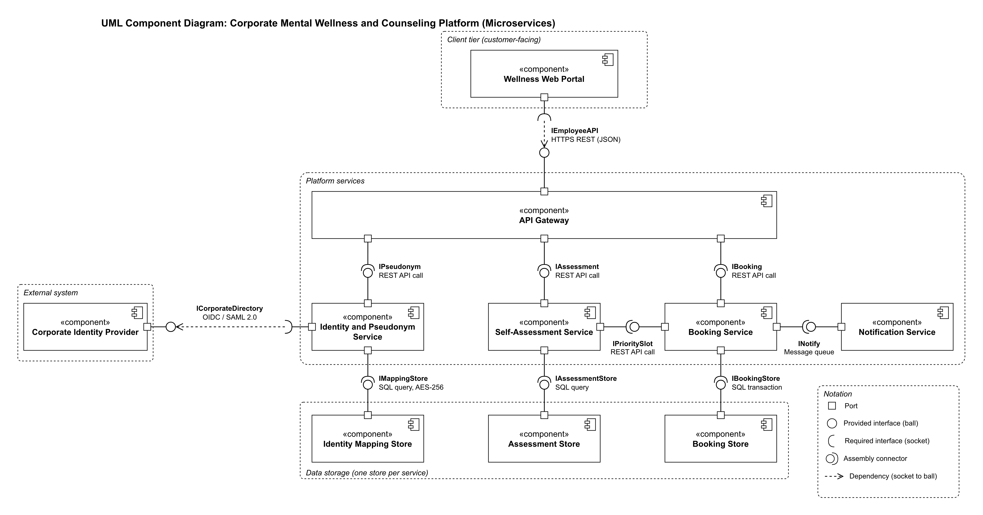
Figure 1. UML component diagram made in draw.io: 10 components, 10 interfaces and a port at every connection point (ball = provided interface, socket = required interface).

2. Written justification
Architecture Selection: We chose Microservices Architecture for the Corporate Mental Wellness and Counseling Platform.
Architectural choice
Microservices. The platform is split into four services (Identity and Pseudonym, Self-Assessment, Booking and Notification) behind one API Gateway. Each service is deployed on its own, and every service that keeps data has its own store. The Wellness Web Portal talks only to the gateway.
Reason 1: the identity mapping has to be kept apart
NFR-002 requires the link between an employee's corporate identity and their pseudo-ID to be stored separately and encrypted. As its own service with its own Identity Mapping Store, the Identity and Pseudonym Service is the only component that can read that link. The Self-Assessment and Booking services receive a pseudo-ID and nothing else, so the separation is enforced by the deployment itself and does not depend on every developer following a coding rule.
Reason 2: the load is uneven and crisis help must keep working
Booking has peak periods, and NFR-001 requires the slot list to load in under 2 seconds at peak load, while self-assessments arrive at a steadier rate. With microservices the Booking Service can be scaled without scaling the rest of the platform. A failure also stays inside one service: if the Notification Service is down, the Self-Assessment Service still scores the questionnaire and shows the crisis helpline for a severe score (FR-005).
Security advantage
A breach stays inside one service. If the Booking Store or the Assessment Store is compromised, the attacker gets pseudo-IDs, scores and time slots but no names, because the identity mapping is kept only in the Identity Mapping Store, encrypted with AES-256 and reachable only through the IMappingStore interface of the Identity and Pseudonym Service. The API Gateway is the single entry point from the internet. It checks the token on every request through IPseudonym and passes only the pseudo-ID to the services behind it.
Performance benefit
Extra instances of the Booking Service can be run at peak time on their own, and its slot queries go to its own Booking Store, so they do not compete with assessment writes in a shared database. This keeps the slot list within the 2-second target of NFR-001. Booking confirmations are handed to the Notification Service through a message queue (INotify), so the employee gets the booking result without waiting for the confirmation to be delivered.

